**Flying High Trust Governance Structure**

**Members**

5 Members  
Custodians of the vision  
Receive Annual Report  
Ensure Board fulfils its responsibilities

**Central Team**

**Board of Trustees**

6 appointed plus CEO  
Responsible for strategic development of The Trust and Teaching School

**Strategic Headteachers**

**PSSD**

Pupils, Standards & Strategic Development Committee

**FPR**

Finance, Personnel & Resources Committee

**Local Hub Board**

(represents 12 schools)

**LGB**

**Local Hub Board**

(represents 12 schools)

**LGB**

**LGB**

**LGB**

**LGB**

**LGB**

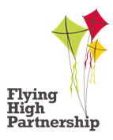

Focus on School Improvement  
Policy implementation across Hub  
Feeds through to Board